Cellular Respiration and Effects of Pollutants on its Rate
(Draft)

Student’s Name: Zhengyi Zhou

Crouse: EVPP-110-001

Instructor: Mangukiya, Rupal
Date: 03/21/2019

Abstract
This experiment is mainly research and understand cellular how to make respiration movement in our life. And research different type of pollution regardless affects the respiration rate of cellular.

Introduction
Cellular respiration is an essential part in our life, because we all need energy to function and we get this energy from the food and water, the most efficient way for cells to harvest energy stored in food is through cellular respiration (Regina Bailey, 2016). As the same time, there are a lot of factors that affect cellular respiration. Such as temperature, concentration of carbon dioxide and pollutes (Iris Hernández, 2017). Through this experiment, we manly consider two parts effect of cellular respiration. Effect of carbohydrate source and effect of a pollutant.
Part A: Find out how carbohydrate effect cellular respiration. We need to establish a comparative experiment. Mix yeast, water with and without sugar. Here sugar as carbohydrate in the experiment. As a result, the hull hypotheses the yeast without the source of sugar will produce more CO2 gas what means has higher rate of cellular respiration than yeast with source of sugar.
Part B: We also consider how the pollutant effect cellular respiration. We choose six different substances as pollutants. They are Isopropyl alcohol, Vinegar, salt solution… The null hypothesis is the yeast will have a higher rate of cellular respiration mixed the source of pollutant than without mixed the source of pollutant.
During this experiment, we measure the volume produced by carbon dioxide to know the rate of cellular respiration. The yeast like us. Yeast need get food from environment to grow and reproduce. In the experiment, the sugar as food to provide energy. As result, produce CO2 gas. This process is mainly cellular respiration. When we mix pollutant into the yeast and sugar, the pollutant reduces the amount of CO2. That because the pollutant gets in the water and contamination of water sources. Yeast won’t get enough water source and pollutant also destroy the structure of yeast and sugar, so yeast produce few CO2 gas.
Method
Part A: We need prepare two 25ml beaker, 2 gas measuring pot, warm water, spoon measuring, yeast, sugar. Experiment number 1: yeast with water only, experiment number 2: yeast, water with sugar. Measure 1.25 ml of yeast and place it into both beaker #1 and beaker #2. Measure 1.25ml of sugar and place into beaker #2, and thoroughly mix sugar and yeast. Measure and add to each beaker 13ml warm water, not hat, tap water. Full stirring to make it mix. Separate the mixture place into the gas measuring pot #1 and gas measuring pot #2. Observe the gas measuring pots reticle and record the volume of gas produced each minute for a period 10 minutes. As the result show in the table 6.1.
Part B: Mix each pollutant (isopropyl alcohol, vinegar, 10% salt solution, 5%, baking soda solution, 1% bleach solution, or 10% soap solution.) with yeast, sugar and warm water into separate gas measuring pot. Observe the gas measuring pots reticle and record the volume of gas produced each minute for a period 10 minutes. As the result show in the table 6.2.

Result
The table 6.1 Gas (CO2) volume (mL) at 1-minute intervals for 10 minutes for culture tube containing yeast and water versus culture tube containing yeast, water, and sugar

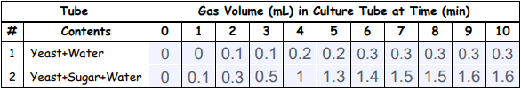
Table 6.1
The table 6.2 Gas (CO2) volume (mL) at 1-minute intervals for 10 minutes for 6 culture tubes, each containing yeast, water, sugar, and one of six simulated pollutants.
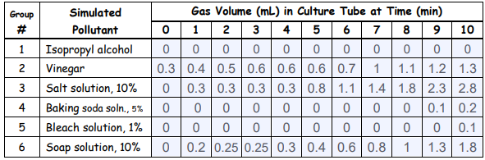
Table 6.2

The table 6.3 Total volume of CO2 produced and cellular respiration rate (mL/min) for 8 combinations of yeast, water, sugar, and simulated pollutant.
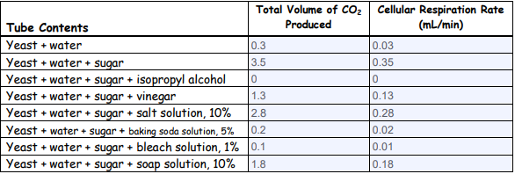
Table 6.3

Discussion
In this experiment, we mainly study sugar and other pollutants effect cellular respiration. Accord table 6.1, We can conclude that sugar can be used as food in the experiment and promotes the production of more carbon dioxide. The hull hypotheses yeast without the source of sugar will produce more CO2 gas what means has higher rate of cellular respiration than yeast with source of sugar were correct. Accord table 6.2 and table 6.3. Different pollutants will have different inhibition of carbon dioxide production.

References
Largen, K., B., Environmental science lab manual and notebook volume 1: The science
Bailey, R (2017) Cellular Respiration Quiz. ThoughtCo. Retrieved from: https://www.thoughtco.com/cellular-respiration-quiz-373395
Walsh, J., & Wuebbles, D. (2014) Climate Change Impacts in the United States. Alaska, Fairbanks: University of Alaska Fairbanks
Hernández, I (2017) What are factors that affect cellular respiration?. Quora. Retrieved from: https://www.quora.com/What-are-factors-that-affect-cellular-respiration

